1. Open Ozene Widget Framework, and click icon  in the left-top. Then you will see:



2.Click , then click create:

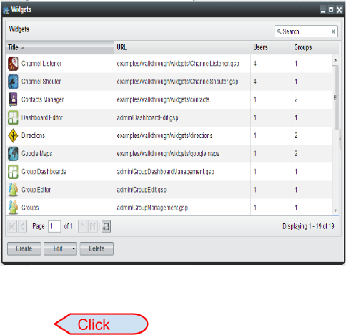

3. Copy the URL of the creating widget, which should be end with .html, and paste on the URL block, and click Load.

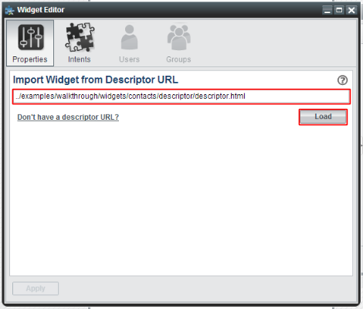

4. System will auto fill all the blanks, just simply click “Apply”.

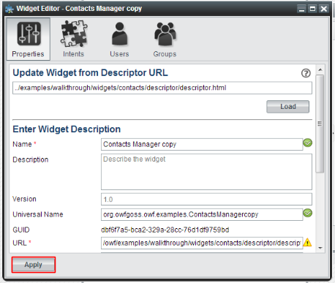

5. When the widget has been save, close the window, you will see the new create widget one the list:

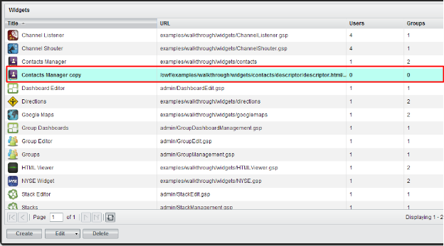

6. Now you can close the window and adding your widget to OWF.